

Trinity International College

(Under the affiliation of Tribhuvan University)

Dillibazar, Kathmandu, Nepal

Tally lab Assignment 3

Submitted to:

Sharmila Bhattarai

Department of Computer Science and Information Technology

Trinity International College

By: Rujen Maharjan

Roll No: 15

Semester: 2nd

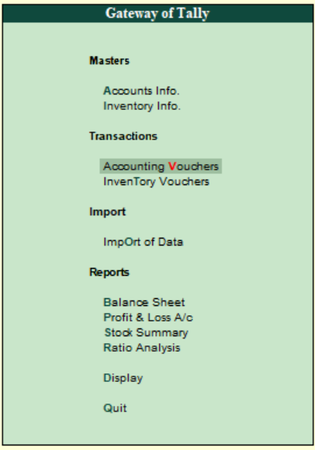**Accounting voucher:**

An accounting voucher is**a documentation** that contains details of a financial transaction. A voucher is considered a document that shows the goods purchased or the services are delivered are paid. The payments are recorded in the respective ledger accounts. For every transaction that is to be recorded, you can use the appropriate Tally voucher to enter the details into the ledgers and update the financial position of the company. The voucher entry menus options are available under Transactions in the Gateway of Tally.

**Pre-defined Voucher:**

Tally is equipped with predefined Vouchers, to suit different business requirements for recording various transactions. Tally also allows you to create user-defined Vouchers as per the users’ requirements. The predefined vouchers in tally are:

* + Contra Voucher
  + Payment Voucher
  + Receipt Voucher
  + Journal voucher
  + Sales Voucher / Invoice
  + Debit Note Voucher
  + Credit Note Voucher
  + Purchase Voucher / Invoice

Tally makes it convenient for the user to reach these predefined vouchers by giving us shortcut key which are shown below:

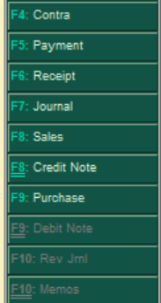

**Contra Entry:-**

 Contra in Latin means the opposite. In the double entry accounting system, a contra entry is an entry which is recorded to **reverse** or **offset** an entry on the other side of an account. If a debit entry is recorded in an account, it will be recorded on the credit side and vice-versa. Debit and credit aspects of a single transaction are entered in the same account but in different columns. Each entry, in this case, is viewed as a contra entry of the other.

As per the Accounting Principles Contra entry refers to transactions involving cash and bank account. In other words, any entry which affects both cash and bank accounts is called a contra entry, transaction indicating transfer of funds such as:

* + Cash account to Bank account
  + Bank account to Cash account

**To create a Contra Entry.**

Go to **Gateway of Tally.**

Click on **Accounting Vouchers** undertransaction section**.**

On right side click on **Contra** or **(F4).**

Here, to show contra entry transferring funds from Cash Account to NMB Bank Account:

Cash Account - Credit.

Bank Account - Debit.

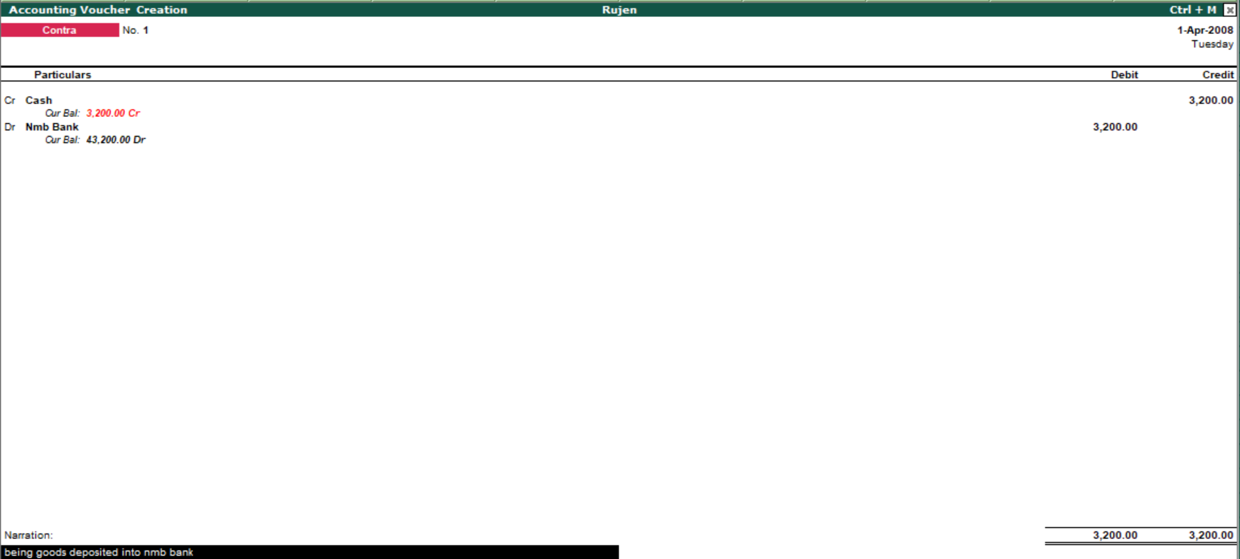

Similarly,

Bank Account - Credit.

Cash Account - Debit.

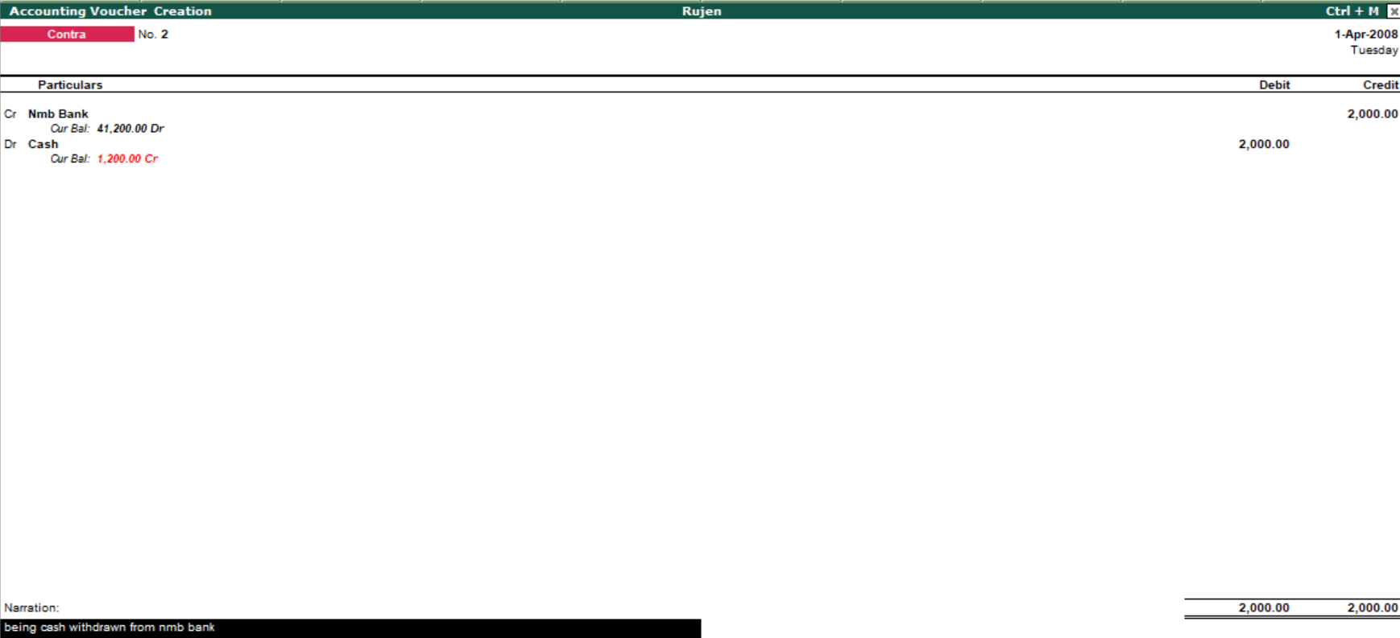

**Deposit - Contra Entry (F4)**

A deposit is money held in a bank account or with another financial institution that requires a transfer from one party to another.

**Example:**

**Cash deposited into the Sanima Bank Rs. 10,000**

Sanima Bank a/c ………………..Dr 10,000

To, Cash a/c……………………………….10,000

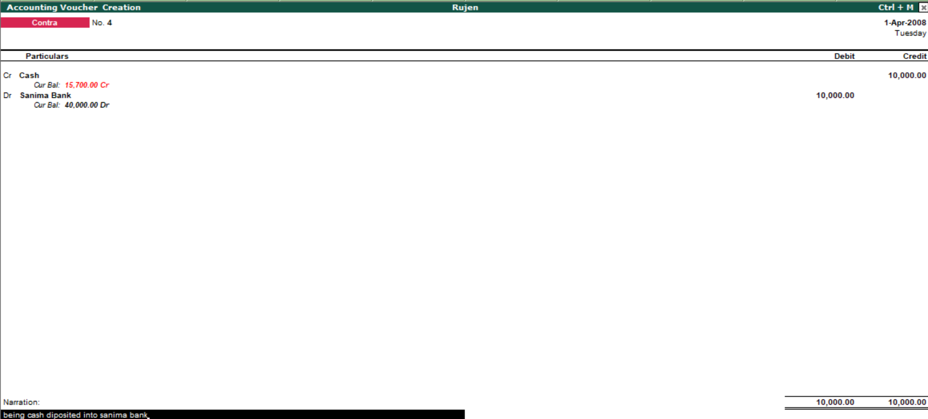

**Cash deposited into the Nabil Bank Rs. 4,500**

Nabil Bank a/c ………………..Dr 4,500

To, Cash a/c……………………………….4,500

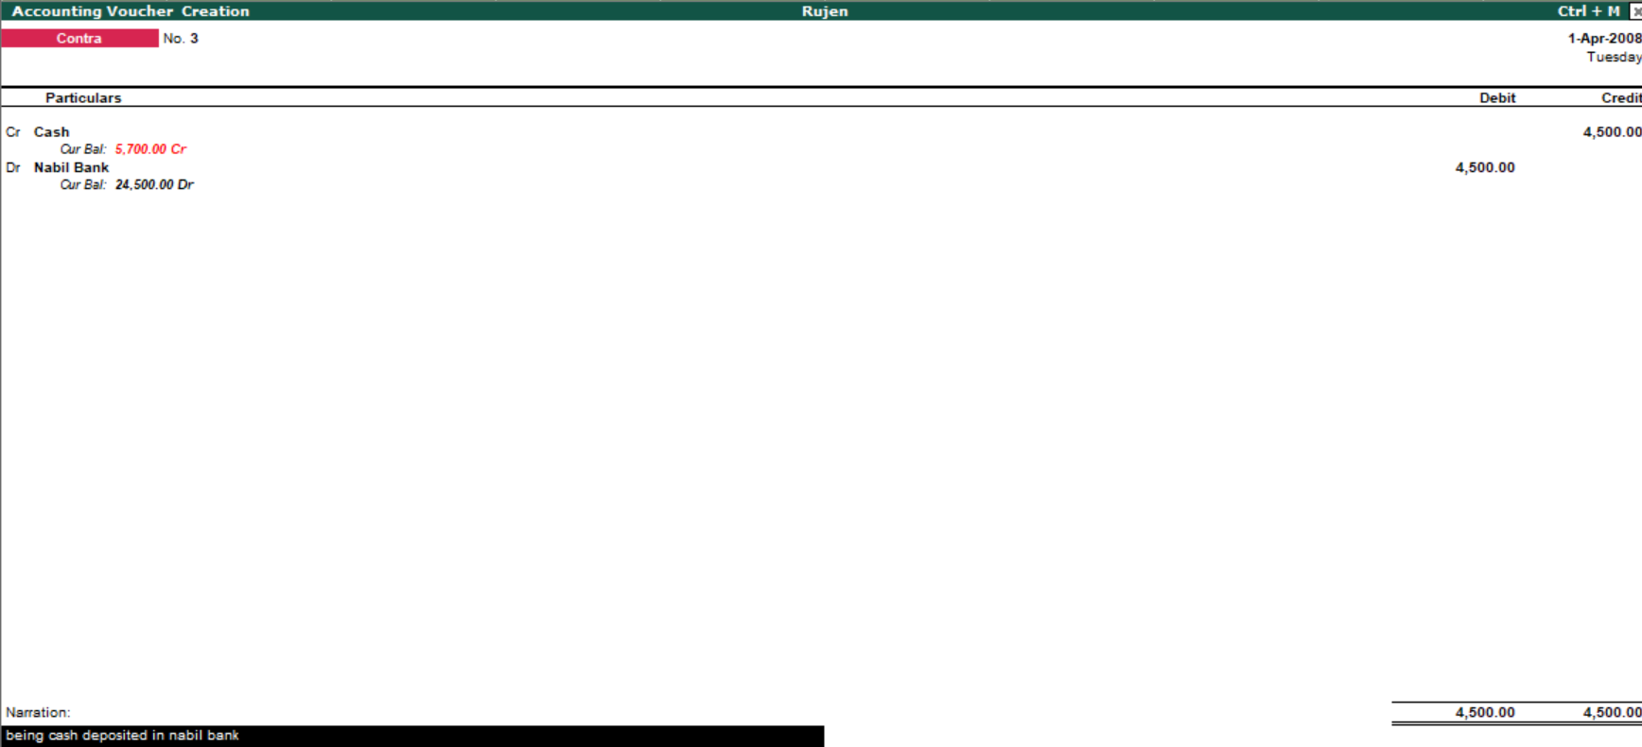

**Withdrawn - Contra (F4)**

It is the process of taking back the money held by the bank. It also involves contra entry. The Cash Withdrawals from Bank report provides the details of Total Amount Withdrawn from bank during the Audit year, along with the voucher count.

**Example:**

**Cash withdrawn from prabhu Bank Rs.5,800**

Cash a/c …………………………...Dr 5,800

To, Laxmi Bank a/c……………………………….5,800

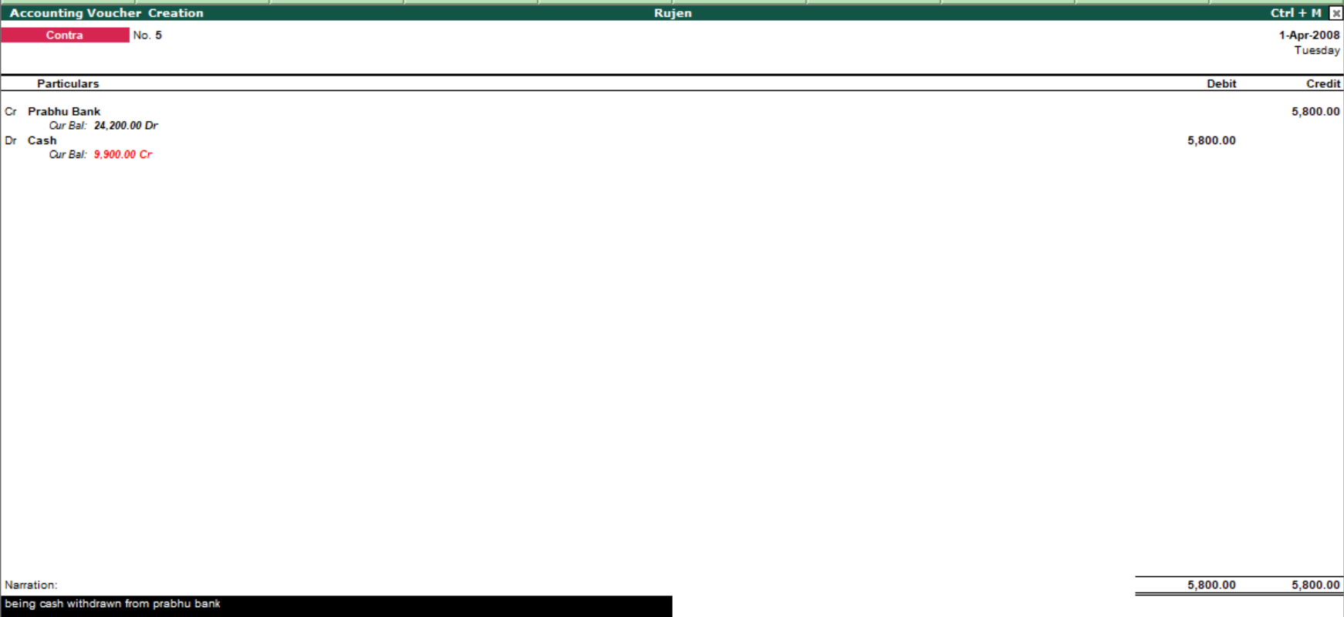

**Cash withdrawn from Nabil Bank Rs.24,000**

Cash a/c ………………………… .Dr 24,000

To, Nabil Bank a/c……………………………….24,000

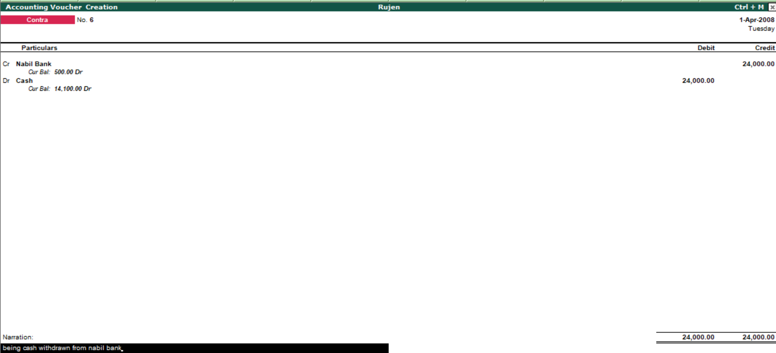

**Payment:-**

Payment is the transfer of money in exchange for goods and services in acceptable proportions that have been previously agreed upon by all parties involved. A payment can be made in the form of services exchanged, cash, cheque. Aninvoiceor bill typically precedes a payment. The buyer usually chooses how they will pay.

**To create a Payment Entry.**



Go to **Gateway of Tally.**

Click on **Accounting Vouchers** undertransaction section**.**

On right side click on **payment** or **(F5).**

**Examples:**

**Rent paid of Rs. 5,200**

Rent a/c ………………………………. Dr 5,200

To cash a/c………………………..…..Rs. 5,200

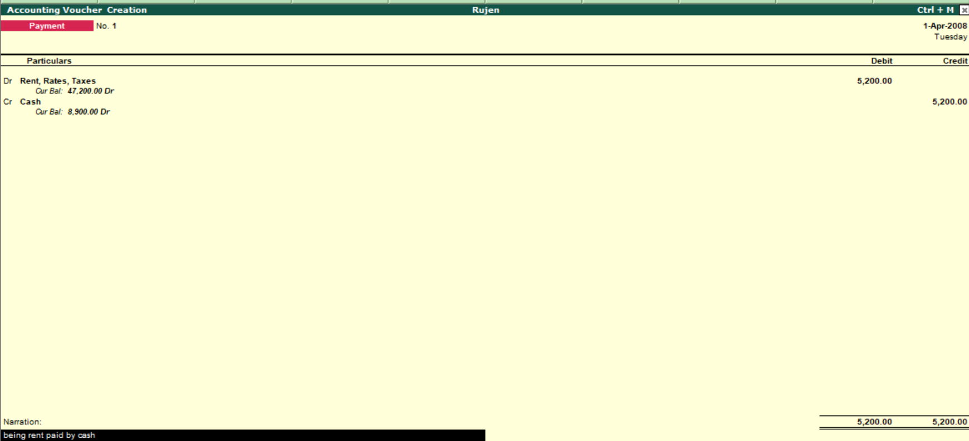

**Commission paid of Rs. 5,200**

Commission a/c ………………………………. Dr 1,700

To cash a/c………………………..…..Rs. 1,700

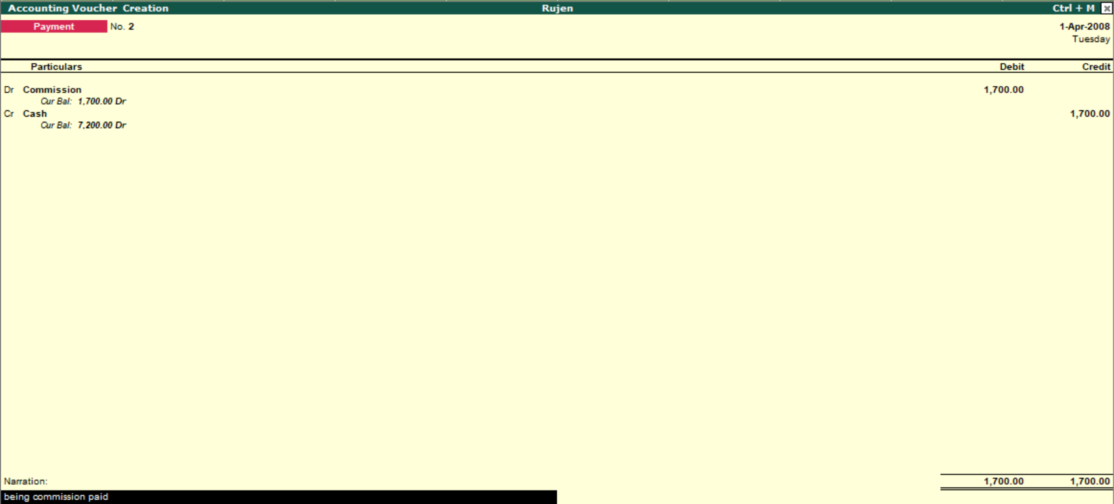

**Receipts:-**

Receipts are the amount of money received by a business during one accounting period. Receipts are cash sales, as well as money received on a customer's account. Receipts also include any cash received in the business from any source, including loan or credit line proceeds or funding from investors.

**To create a Receipts Entry.**



Go to **Gateway of Tally.**

Click on **Accounting Vouchers** undertransaction section**.**

On right side click on **Receipt** or **(F6).**

**Examples:**

**Interest received of Rs. 25,000**

Cash a/c ……………………… Dr 25,000

To interest received a/c ……………… 25,000

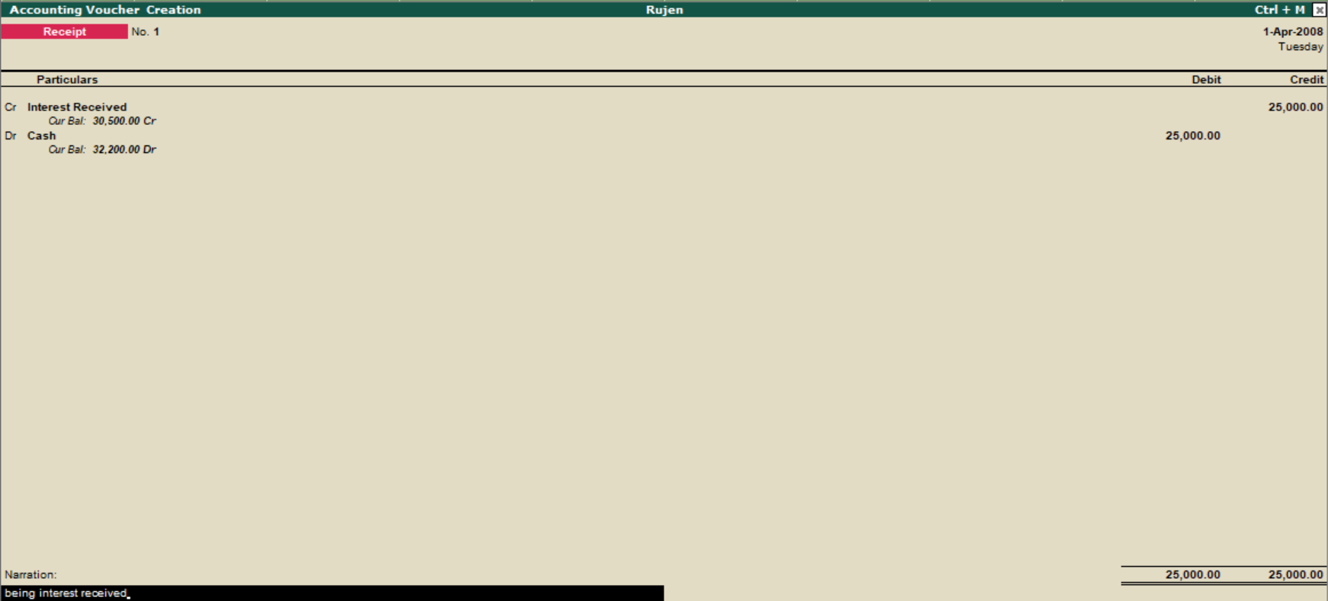

**Rent received of Rs. 25,000**

Cash a/c ……………………… Dr 25,000

To rent received a/c ……………… 25,000

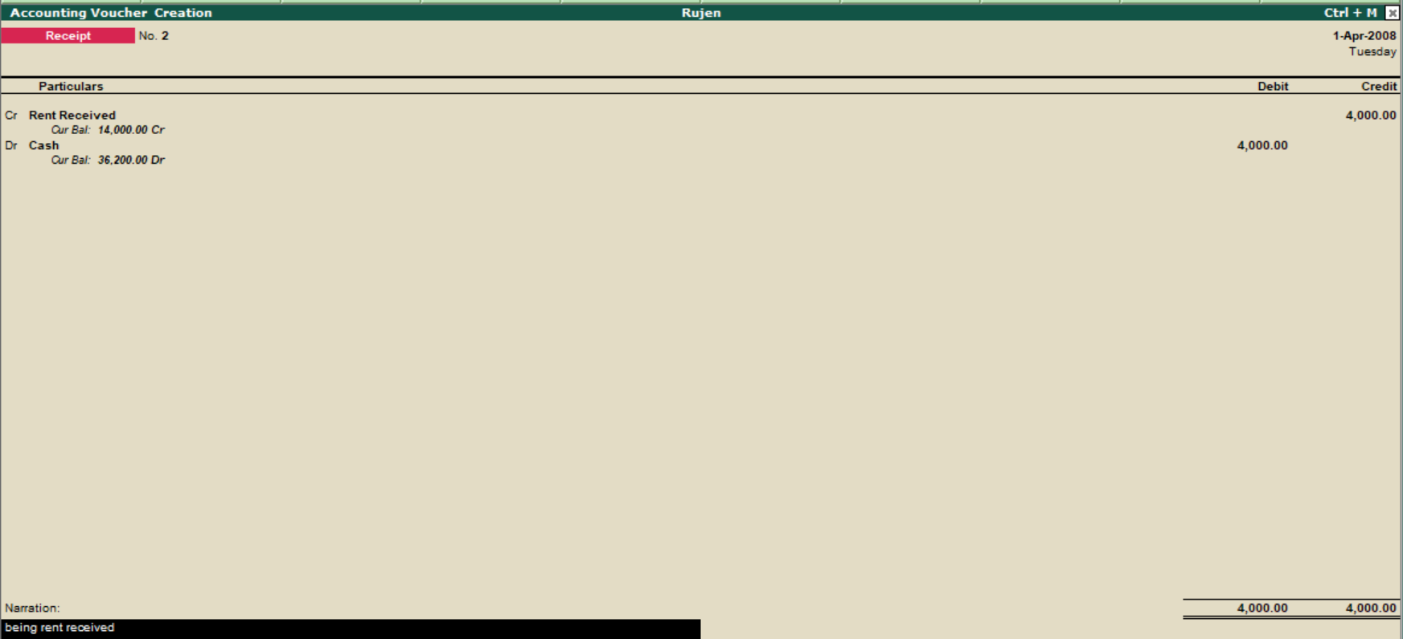

**Journal:-**

A journal is**a detailed account that records all the financial transactions of a business, to be used for the future reconciling of accounts and the transfer of information to other official accounting** records, such as the general ledger. But in tally we only record the payables or receivables since payment and receipts are already there.

**To create a journal Entry.**



Go to **Gateway of Tally.**

Click on **Accounting Voucher** under transaction section.

On right side click on **journal** or **(F7).**

**Examples:**

**Wages payable of Rs. 3700**

Wages a/c ……………………… Dr 3700

To o/s wages a/c …………….………… 3700

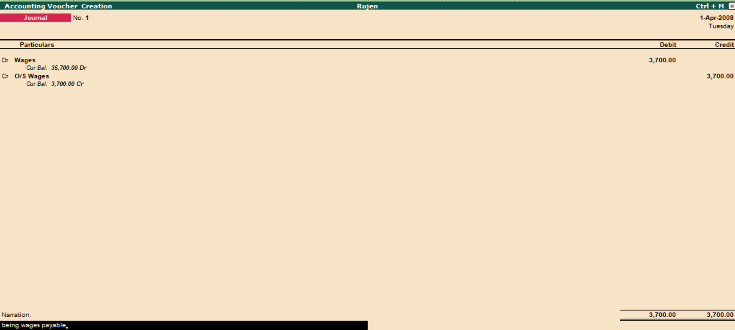

**Salary payable of Rs. 43,000**

Salary a/c ……………………… Dr 43,000

To O/S salary a/c ……………… 43,000

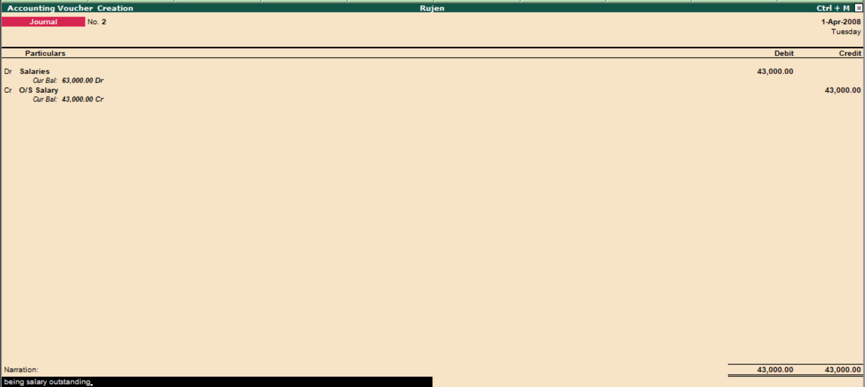

To view all the entries of **contra, receipts, payment** we have to follows the following steps:-

* Go to **Gateway of Tally.**
* Click on **Display** on Reports Section.

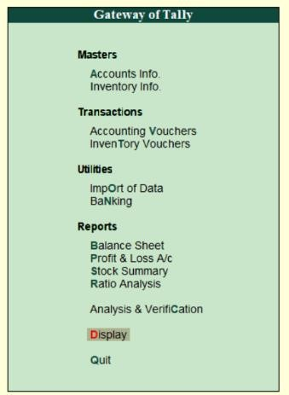

* Click on **Day Book.**

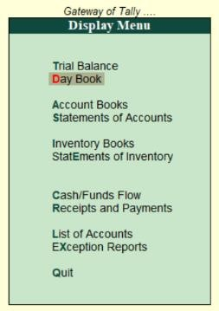

* And see the all entries.

